
JET Programme

7.00 – 9.00pm

Date | Activity
5th  November | Casino Night | 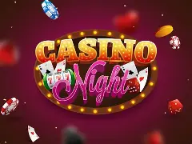
12th  November | Karaoke | 
19th  November | Musical Bingo | 
26th  November | End of Month  Disco | 

£5:00 Entry and refreshments available to purchase
For any comments, suggestions or queries regarding the activity
programme please contact the Club Leader Leanne Court or the Deputy Manager Sue Larkin Tel: 01252 313103
Email: Leanne.court@parksidealdershot.co.uk
Sue.larkin@parksidealdershot.co.uk
JET Programme

7.00 – 9.00pm

Date | Activity
5th  November | Casino Night | 
12th  November | Karaoke | 
19th  November | Musical Bingo
26th  November | End of Month  Disco

£5:00 Entry and refreshments available to purchase
For any comments, suggestions or queries regarding the activity
programme please contact the Club Leader Leanne Court or the Deputy Manager Sue Larkin Tel: 01252 313103
Email: Leanne.court@parksidealdershot.co.uk
Sue.larkin@parksidealdershot.co.uk

