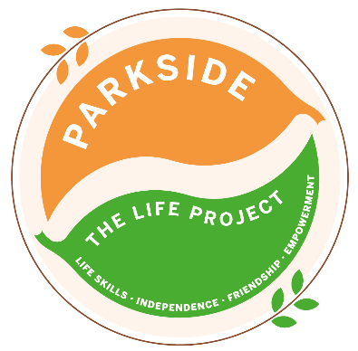
Friday
The LIFE Project Programme –
September 2026
9.30am – 3.30pm Activity Room Parkside

Life Skill Focus: Team Development and Growth


DATE | MORNING | AFTERNOON
4th September | Dawn Barge boat trip from Odiham
4th September | Laser Tag | October Programme Planning  Team Scavenger Hunt in Aldershot Park
11th September  LP PLUS GROUP A | Play a Game of football in Frimley Lodge Park  Write or draw kind and motivating words about your friends at the LIFE Project on paper strips. Then join the strips together to make a paperchain | Picnic lunch then play a game of Cricket  Zumba with Smiley Jo
18th September | Bowling at Guildford Spectrum for Lee’s Birthday | In teams complete a visual Maze Navigation
25th September  LP PLUS GROUP B | The Great Box challenge Each team to transform their box into something creative  Write or draw kind and motivating words about your friends at the LIFE Project on paper strips. Then join the strips together to make a paperchain | In teams complete a general knowledge quiz  Zumba with Smiley Jo
2nd October  LP PLUS GROUP C | As a team complete the Marlborough trail in Farnborough  Write or draw kind and motivating words about your friends at the LIFE Project on paper strips. Then join the strips together to make a paperchain | Play the parachute game in Parkside’s garden  Zumba with Smiley Jo

For each session please bring suncream and a packed lunch unless stated otherwise, plus your £5 Activity Fee
For any comments suggestions or queries regarding the activity programme please contact the Club Leader, Leanne Court or Mandy Wickins or the Deputy Manager, Angie Morris Tel: 01252 313103 or email Leanne.court@parksidealdershot.co.uk or Mandy.wickins@parksidealdershot.co.uk or angie.morris@parksidealdershot.co.uk

