
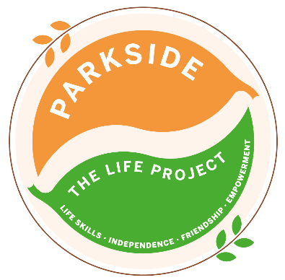
WEDNESDAY
The LIFE Project Programme –
August 2026
9.30am – 3.30pm Activity Room Parkside

Life Skill Focus: Independent Living skills

DATE | MORNING | AFTERNOON
5th  August  No Packed Lunch Required | ‘Summer of Fun Week’  Making Rice Crispy Squares for Life Project Fundraiser | ‘Summer of Fun Week’  BBQ & Karaoke
12th  August | Recreation and Hygiene  Shopping for Personal Care items | Personal Care & Pamper Afternoon
19th  August  No Packed Lunch Required | Personal Boundaries  As a group research the meaning of ‘Personal Boundaries’ | Lunch out at Weatherspoon’s to celebrate Eric’s birthday
26th August | Outdoor Survival and First Aid  *SMART Target Reviews & Rewards*  Visit Virgina Waters to practice staying safe whilst near deep water | Search for;  Emergency Services, A Defibrillator,  A First Aid Station & A First Aid Person
For each session bring sun cream and a packed lunch unless stated otherwise, plus your £5 Activity Fee
For any comments suggestions or queries regarding the activity programme please contact the Club Leader, Mandy Wickins or the Deputy Manager, Angie Morris Tel: 01252 313103 or email
mandy.wickins@parksidealdershot.co.uk or angie.morris@parksidealdershot.co.uk

