
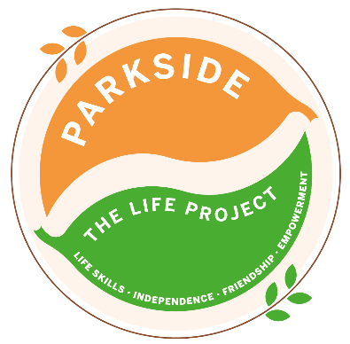
Tuesday
The LIFE Project Programme –
August 2026
9.30am – 3.30pm Activity Room Parkside

Life Skill Focus: Independent Living skills

DATE | MORNING | AFTERNOON
4th August | ‘Summer of Fun Week’  Baking ‘Old School Tray Bake’ for Life Project Fundraiser | ‘Summer of Fun Week’  Musical Bingo
11th August | Recreation & Hygiene  Minigolf at Junglemania | How well do we clean our teeth?  (Please bring in toothbrush & toothpaste from home)  Cleaning our teeth after lunch  Personal hygiene quiz
18th August | Personal Boundaries  Research what it means to be in ‘someone’s personal bubble’  Group discussions and scenarios | Group walk in the community to practice what we’ve learnt about ‘personal space and personal boundaries’
25th August | Outdoor Survival and First Aid  *SMART Target Reviews & Rewards*  Working together to build a shelter that at least half of the group can sit under | Practicing First Aid and Emergency skills whilst accessing the community
For each session bring sun cream and a packed lunch unless stated otherwise, plus your £5 Activity Fee
For any comments suggestions or queries regarding the activity programme please contact the Club Leader, Jade Letham or the Deputy Manager, Angie Morris Tel: 01252 313103 or email jade.letham@parksidealdershot.co.uk or angie.morris@parksidealdershot.co.uk

