
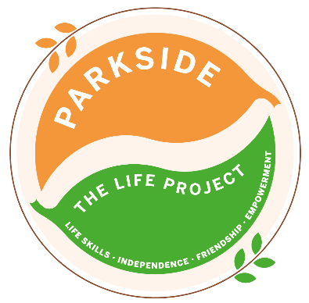
Monday Group B
The LIFE Project Programme –
August 2026
9.30am – 3.30pm Activity Room Parkside

Life Skill Focus: Independent Living skills

DATE | MORNING | AFTERNOON
3rd  August | ‘Summer of Fun week’  Baking Hawaiian Cakes Life project Fundraiser | ‘Summer of Fun week’  Hawaiian Zumba with Jo
10th  August | Personal Boundaries  Build a personal shield with your chosen resources | Using your Personal shield protect yourself in a water fight in the garden
17th  August | Outdoor Survival and First Aid  Group vote on chosen woodland hike Find the local defibrillator | Explore what resources would be available if we were injured while outdoors
24th August | Recreation and Hygiene  *SMART Target Reviews & Rewards*  Play a game of Basketball at Manor Park A picnic lunch | Freshen up and Pamper afternoon at Parkside
For each session, please bring sun cream and a packed lunch unless stated otherwise, plus your £5 Activity Fee
For any comments suggestions or queries regarding the activity programme please contact the Club Leader, Jade Letham or the Deputy Manager, Angie Morris Tel: 01252 313103 or email jade.letham@parksidealdershot.co.uk or angie.morris@parksidealdershot.co.uk

