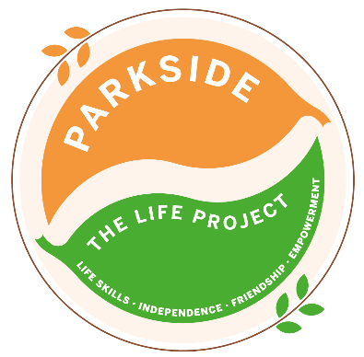

Friday
The LIFE Project Programme –
August 2026
9.30am – 3.30pm Activity Room Parkside

Life Skill Focus: Team Development and Growth

DATE | MORNING | AFTERNOON
LP PLUS GROUP A | Practising safe and effective ways to keep our homes clean and hygienic | Zumba with Smiley Jo
LP PLUS GROUP B | Practising safe and effective ways to keep our homes clean and hygienic | Zumba with Smiley Jo
LP PLUS GROUP C | Practising safe and effective ways to keep our homes clean and hygienic  * | Zumba with Smiley Jo  Enjoy a BBQ and Smores

For each session please bring suncream and a packed lunch unless stated otherwise, plus your £5 Activity Fee
For any comments suggestions or queries regarding the activity programme please contact the Club Leader, Leanne Court or Mandy Wickins or the Deputy Manager, Angie Morris Tel: 01252 313103 or email Leanne.court@parksidealdershot.co.uk or Mandy.wickins@parksidealdershot.co.uk or angie.morris@parksidealdershot.co.uk

