
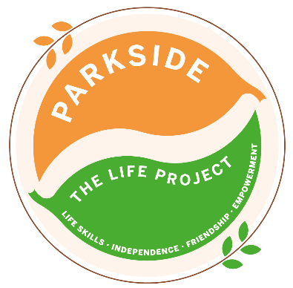
Tuesday
The LIFE Project Programme –
July 2026
9.30am – 3.30pm Activity Room Parkside

Life Skill Focus: Independent Living skills

DATE | MORNING | AFTERNOON
7th July  No packed lunch required | Leisure, Hobbies and Recreation  August programme planning and SMART target setting  A morning of gaming with friends |       Meal out at New Inn (Hungry Horse) to celebrate Sam’s birthday!
14th July  No packed lunch required | Meal prep, Nutrition and Kitchen skills  Shopping for ingredients to make Chicken Fajita’s and a fruit salad  Prepare and cook Chicken Fajita’s safely and hygienically for our lunch | Make and prepare a fruit salad for dessert
21st July | Community Navigation and Safety  Researching a bus route and timetable to groups chosen destination | Picnic lunch and group discussion around keeping safe in the community, who can help us if we have a problem?
28th July | Safety in the home and household management  Bring in one dirty item of clothing from home to wash and dry at Parkside | Group discussion about the importance of keeping your home clean and tidy
For each session bring sun cream and a packed lunch unless stated otherwise, plus your £5 Activity Fee
For any comments suggestions or queries regarding the activity programme please contact the Club Leader, Jade Letham or the Deputy Manager, Angie Morris Tel: 01252 313103 or email jade.letham@parksidealdershot.co.uk or angie.morris@parksidealdershot.co.uk

