
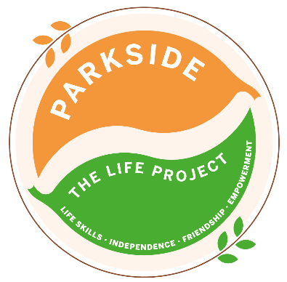
FRIDAY
The LIFE Project Programme – March 2026
9.30am – 3.30pm Activity Room Parkside

Life Skill Focus: Caring for Others and Working Together

DATE | MORNING | AFTERNOON
6th March  **********  LP PLUS GROUP A | April programme planning, setting SMART targets. Shopping for food items, then donate to a food bank  **********************************April programme planning, setting SMART targets. Shopping for ingredients, then making Bird Fat Balls to sell and raise money for the RSPCA charity | Collectively as a group walk 5km around Tice’s Nature reserve to fundraise for Make a Wish Foundation  ********************************  Zumba with Smiley Jo
13th March  **********  LP PLUS GROUP B | Shopping for a Mother/Carer’s Day presents in Camberley  **********************************Shopping for ingredients, then making Bird Fat Balls to sell and raise money for the RSPCA charity | Collectively as a group swim 5km to fundraise for Make a Wish Foundation  ********************************Zumba with Smiley Jo
20th March  **********  LP PLUS GROUP C | Comic relief Fun day with PIP  **********************************Shopping for ingredients, then making Bird Fat Balls to sell and raise money for the RSPCA charity | Fancy dress Zumba with Smiley Jo  ********************************Fancy dress Zumba with Smiley Jo
27th March No packed lunch required | Litter picking at Frensham Pond, Lunch at groups chosen venue | Collectively as a group walking 5k to fundraise for Make a Wish Foundation
3rd April | Closed for Good Friday/Bank Holiday | Closed for Good Friday/Bank Holiday
For each session bring sun cream and a packed lunch unless stated otherwise, plus your £5 Activity Fee
For any comments suggestions or queries regarding the activity programme please contact the Club Leader, Leanne Court or Jade Letham or the Deputy Manager, Angie Morris Tel: 01252 313103 or email Leanne.court@parksidealdershot.co.uk or jade.letham@parksidealdershot.co.uk or angie.morris@parksidealdershot.co.uk

